Predictive Analysis of Vehicular Emission Pattern: Identifying High-Impact Vehicles and Sustainable Fuel Alternatives

**Optimizing Vehicle Emissions: Identifying High-Impact Vehicles and Exploring Sustainable Fuel Options**

**Abstract.** Urbanization and an increase in automobile traffic have worsened air pollution and public health issues worldwide. This study examines the emissions produced by passenger cars, focusing on the environmental benefits of hybrid vehicles over those powered by conventional fossil fuels. Even though they have a smaller impact on the environment, hybrid automobiles are still less common due to their higher prices and limited production. We have collected and preprocessed a comprehensive dataset of vehicular emissions, including real-time measurements and aggregated data, to analyze the relationship between fuel consumption and CO2 emissions. Through feature engineering, we enhanced the dataset by incorporating key attributes such as vehicle type, price, and operational metrics. A Linear Regression Model was developed to explore the correlation between fuel consumption and CO2 emissions, demonstrating a positive linear relationship. In order to encourage the use of hybrid vehicles and lower overall emissions, our findings highlight the need for stringent regulations and financial incentives. Policymakers and stakeholders aiming to develop environmentally friendly transportation options and improve air quality will benefit from this study's insightful findings.

**Keywords:** Real-time vehicle emissions, environmental pollution, data analysis, mitigation strategies, predictive modeling, sustainable transportation.Battery electric vehicle (BEVs),fuel cell electric vehicle (FCEV).

1. Introduction

The growth of city populations worldwide has caused a large increase in traffic jams and worsening air pollution. Car emissions, which release harmful pollutants such as carbon monoxide (CO), nitrogen oxides (NO), particulate matter (PM), and volatile organic compounds (VOCs), are a major reason for worsening air quality [1]. These pollutants not only endanger people's health but also contribute to environmental problems such as climate change. In the past, vehicle emissions were mostly checked during inspections or at fixed monitoring stations set up by manufacturers after making their vehicles. However, these methods do not provide a clear picture of how emissions change when cars are actually driven on the road. Owing to new sensor technology (OBFCM), data analysis, and Internet-connected devices (IoT), we can now collect real-time data on vehicle emissions [7][4]. This helps us understand the pollution dynamics on roads much better than before. With this newfound knowledge, we can take proactive steps towards reducing pollution levels and creating cleaner and healthier environments for all.

Vehicle emissions are seriously polluting the air as a result of urbanization's significant increase in vehicle traffic. Several factors are primarily to blame for this issue. To begin, the combustion of fossil fuels in automobiles results in the release of harmful pollutants like carbon monoxide and nitrogen oxides, both of which contribute to air pollution and pose serious health risks. Second, the unpredictability of urban traffic patterns encourages prolonged idling and stop-and-go driving, both of which contribute to an increase in emissions, making traffic congestion even worse. Last but not least, the age of the vehicle and how well it is maintained are important factors. Older vehicles with old or failing emission control systems tend to produce more pollutants, which lowers air quality even further [2][7]. Vehicle emissions, when taken together, are a major cause of urban air pollution, highlighting the urgent need for cleaner transportation options.

Vehicle pollution has numerous and far-reaching effects on both human health and the environment. The incidence of asthma and bronchitis rising among those who breathe in polluted air is one of the most significant effects on respiratory health. Long-term exposure to pollution in the air has also been linked to cardiovascular diseases like hypertension and heart attacks. Exposure to pollutants can also cause neurological problems, and studies have linked air pollution to diseases like Alzheimer's. Emissions from motor vehicles harm natural ecosystems in addition to human health. Pollutants harm vegetation and water bodies, causing environmental imbalances. Animals' patterns of foraging, navigation, and communication change, affecting their behaviour as well. Changes in the migration routes of avian populations, difficulties with reproduction, and respiratory distress have all been observed [5]. Effective mitigation strategies and sustainable urban development require a thorough understanding of these diverse effects.

# 2 Literature Review

Both urban air pollution and global greenhouse gas emissions are significantly affected by vehicle emissions. It is necessary to comprehend actual vehicle emissions for effective policies and technologies to reduce these effects. Current research on real-world vehicle emissions is examined in this literature review, which highlights key findings, methods, and literature gaps.

Over the years, research on vehicle emissions has shifted from laboratory tests to real-world measurements. Initially, emissions were measured in labs that did not show a full picture of actual driving situations. However, thanks to portable emission measurement systems (PEMS), we can gather data on real-world emissions. These systems give us a better idea of vehicle emissions in different driving conditions [3][4][6].

**Current Research Standing:** Measurements of actual vehicle emissions have been performed using a variety of approaches in recent studies. A Predictive Emission Monitoring System (PEMS) is widely used to measure pollutants such as nitrogen oxides (NOx), particulate matter (PM), carbon monoxide (CO), and carbon dioxide (CO2) while driving. Different methods incorporate remote detection, which distinguishes discharges from passing vehicles, and information investigation from installed indicative frameworks (OBD), which provide bits of knowledge into vehicle execution and outflows [7][2].

**Factors Affecting Emissions:** A Several factors, such as fuel type, driving habits, vehicle maintenance, and environmental conditions, affect actual vehicle emissions. Frequent acceleration and deceleration, together with aggressive driving, can significantly increase the NOx and CO emissions. Pollution emissions from poorly maintained automobiles are often higher than those from well-maintained automobiles. Furthermore, the type of fuel used might affect emissions, and NOx levels from diesel engines are often higher [2][13].

Concerns about the accuracy of emissions data have been raised as a result of comparison studies revealing significant discrepancies between laboratory-based emission tests and actual measurements. Real Driving Emissions (RDE) regulation has been proposed to address these inconsistencies. In order to guarantee that vehicles meet emission standards under real-world conditions, this regulation aims to close the gap between lab-based emissions tests and actual driving emissions. The use of Portable Emission Measuring Systems (PEMS), which monitor pollutants in real time while a vehicle is operating, is one of this effort's most important tools. This gives a more accurate picture of emissions when driving every day. It is anticipated that the incorporation of RDE into the procedures for the certification of vehicles will have a beneficial effect on the global air quality by ensuring that vehicles perform as anticipated in actual-world conditions. This document makes use of a number of studies and articles that emphasize the significance of on-road emission factors and real-world driving emissions [2][4]. Emission regulations based solely on laboratory tests have raised questions about their efficacy due to the discrepancies between laboratory and real-world emissions, highlighting the need for more comprehensive and accurate testing methods.

The Indian Institute of Technology Kanpur's Department of Mechanical Engineering's Engine Research Laboratory is at the forefront of efforts to control and monitor real-world automotive emissions. The Department of Mechanical Engineering at Rajshahi University of Engineering & Technology in Bangladesh summarizes their research, which focuses on a number of important aspects of emission control. The difficulties in accurately capturing real-world data are brought to light as the paper compares and contrasts on-board and laboratory-based methods for monitoring vehicle emissions. In addition, it looks into the most recent developments in emission control technologies, such as after-treatment solutions, alternative fuels, and cutting-edge engine innovations, all of which are aimed at lowering emissions of greenhouse gases. In addition, the study emphasizes the significance of efficient transportation planning for efficient traffic management, which is critical to reducing emissions. In order to contribute to the creation of a road transportation system that is both environmentally friendly and cost-effective, the paper offers guidelines for the precise monitoring of actual vehicle emissions.

Key findings on the connection between vehicle emissions and real-world driving conditions are presented in the research paper Real World Vehicle Emissions: Their Correlation with Driving Parameters [9]. Using models to estimate the difference between real-world conditions and standardized testing cycles like the Worldwide Harmonized Light Vehicles Test Procedure (WLTP), the study simulated emissions for gasoline-powered light passenger cars. When compared to predictions made in the laboratory, the higher emissions observed during actual road use were strongly correlated with a number of driving parameters. One significant finding was that emissions were significantly higher than predicted by the WLTP in real-world driving patterns, which were characterized by lower average speeds and more frequent accelerations. This discrepancy demonstrates how poorly current testing cycles accurately represent actual conditions. The study also suggests that future efforts should focus on creating a driving cycle that is more realistic and better reflects the driving conditions in Tier-II Indian cities [8][11]. The goal is to close the gap between predictions made in the lab and emissions from the real world.

Deployment of [alternative fuel](https://www.sciencedirect.com/topics/engineering/alternative-fuel) vehicles (AFVs) operating on cleaner fuels than traditional [petroleum fuels](https://www.sciencedirect.com/topics/engineering/petroleum-fuel) can provide significant potential to reduce GHGs and [toxic pollutants](https://www.sciencedirect.com/topics/earth-and-planetary-sciences/toxic-pollutant) ([U.S. DOE, 2013](https://www.sciencedirect.com/science/article/pii/S0967070X24000313?via%3Dihub" \l "bib54)). Accordingly, California has made considerable investment in alternative fuel infrastructure developments and vehicle demonstrations along with various deployment incentive programs, such as via the Clean Transportation Program, which provided up to $100 million of annual funding ([CEC, 2020a](https://www.sciencedirect.com/science/article/pii/S0967070X24000313?via%3Dihub" \l "bib24)), and the Clean Transportation Incentives, which provided approximately 29 million to 2.6 billion annually ([CARB, 2022a](https://www.sciencedirect.com/science/article/pii/S0967070X24000313?via%3Dihub" \l "bib18)) [14].

Next to pollutant emissions, GHG emissions from road transport are a major concern due to their contribution to climate change. In the last two decades, regulations in the EU have encouraged the development and incorporation of renewable fuels for transport with a view to reduce its carbon footprint [18].

Electric vehicles (EVs) have emerged as a promising solution to the negative impacts associated with internal combustion engine vehicles (ICEs) in the transportation sector. Their growing popularity can be attributed to several key advantages they offer over their ICE counterparts [[15]](https://www.sciencedirect.com/science/article/pii/S1110016823009055?via%3Dihub" \l "b0155)[[16]](https://www.sciencedirect.com/science/article/pii/S1110016823009055?via%3Dihub" \l "b0160)[[17]](https://www.sciencedirect.com/science/article/pii/S1110016823009055?via%3Dihub" \l "b0165).

When compared with conventional vehicles, the CO2 emissions of BEVs and FCEVs are lower in most cases. The CO2 emissions were higher for the FCEVs if the hydrogen was obtained via the gasification of coal or grid-powered electrolysis. Therefore, both BEVs and FCEVs can be considered as alternatives to conventional vehicles [19].

An in-depth look at a number of crucial aspects of emissions testing and control can be found in the article On-Road Emissions of Passenger Cars Beyond the Boundary Conditions of the Real-Driving Emissions Test. It investigates the EU's implementation of Real-Driving Emissions (RDE) test methods, which evaluate passenger vehicle emissions during on-road operations, with a particular focus on NOx and PN emissions. The review features progressions in outflow control advances for both diesel and gas vehicles, taking note of that these enhancements have prompted more powerful discharge decreases under true driving circumstances. In spite of these advancements, the research emphasizes the need for additional focus on PN and carbon monoxide (CO) emissions, particularly when driving in dynamic conditions. To fully address these emissions, the study suggests that additional work is required [10]. A technology-neutral approach to vehicle emission standards is also supported by the findings. This strategy promotes fairness and consistency in environmental regulations by ensuring that all vehicles adhere to the same emission limits regardless of their technology or fuel type.

1. Methodology

This methodology provides a framework for accurate analysis of vehicle emissions. Collected data are processed to reduce noise, null values. The processed data are integrated, and further features are selected to remove unwanted features. Various statistical methods will be used to extract inferences from the selected data. These inferences are further used for model building. Model is trained on train data and tested for performance analysis. Based on analysis some conclusions and suggestions are recommended.

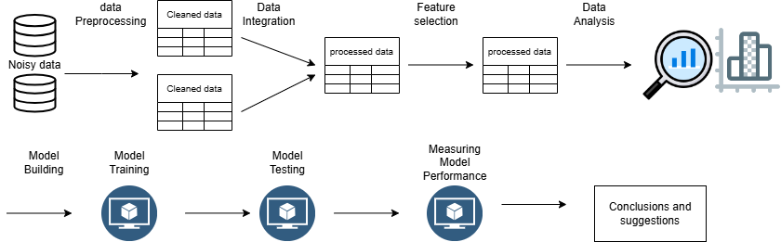

**Fig 0.**  Methodology of Data analysis

# 3.0 Data Set Description:

The Real-Time Vehicular Emission Dataset is an extensive collection of emission-related data for cars and vans consisting of two distinct datasets. The first dataset, which encompasses raw data for cars and vans, contains 928,573 tuples with 14 attributes and is approximately 55,000 KB in size. This dataset provides comprehensive raw data, including information on fuel consumption, fuel type, CO2 emissions, and other emission-related parameters, serving as a foundational dataset for analyzing the real-time emission characteristics of various vehicles under different conditions.

The second dataset comprised aggregated data for cars and vans, containing 134 tuples with 20 attributes and a file size of 18 KB. The data is aggregated by manufacturers and fuel types. This dataset offers aggregated information derived from raw data, including summary statistics and key metrics that encapsulate the overall emission profiles of vehicles. Covering a wider range of parameters provides a holistic view of emission trends, aiding higher-level analysis and reporting.

Some important attributes are as follows.

* *OBFC Monitor:* It stands for "On-Board Fuel Consumption Monitor.” This refers to a system or device installed in vehicles to monitor and display real-time resource consumption/emission rates, typically measured in litres per 100 kilometres (l/100 km).
* *WLTP Measure:* It refers to the resource consumption/emission of a vehicle measured using the Worldwide Harmonized Light Vehicles Test Procedure (WLTP). WLTP is a globally harmonized test cycle for measuring vehicle emissions and fuel consumption, designed to provide more accurate and realistic data compared to previous testing procedures.
* *Absolute gap consumption:* This likely refers to a parameter or measurement related to the difference between the actual fuel consumption of a vehicle and a benchmark or target fuel consumption rate.
* *OBFCM Fuel consumption weighted:* This likely refers to a weighted average of fuel consumption for a group of vehicles or a specific vehicle model.
* *Driver-selectable charge increasing operation:* refers to the value recorded while the driver has chosen to increase the charge of the vehicle’s battery. This typically indicates the value recorded while actively engaging in charging operations manually selected by the driver, such as using regenerative braking, plugging into a charging station, or any other method available to increase the battery charge level. This metric helps gauge the usage of electric or hybrid vehicles in terms of actively replenishing their energy sources over a vehicle's lifetime.
* *In the charge-depleting operation:* this suggests that the vehicle is operating in a mode where it primarily uses the energy stored in its battery (i.e., in electric mode) rather than relying on the internal combustion engine.
* *Total grid energy into the battery (lifetime) (kWh):* The total grid energy transferred into the vehicle's battery over its lifetime, measured in kilowatt-hours.

These datasets are invaluable for analysts focused on studying vehicular emissions, environmental impacts, and fuel efficiency, enabling the development of models for predicting emissions, optimizing fuel consumption, and formulating policies aimed at reducing the environmental footprint of road transportation.

**3.1 DATASET PREROCESSING:**

In this phase of advanced data pre-processing, our aim was to further enhance the predictive power of our model beyond what basic feature engineering was initially provided. Through careful analysis and insights drawn from the Kaggle competition and the research community, we identified the need to handle noisy data and incorporate additional parameters into our dataset.

The raw data before preprocessing consists of 928570 tuples and 13 features, after data processing, feature removing and adding extra features the data consists of 439533 tuples 10 features. The aggregated data consist of 134 tuples and 19 features before processing. After processing the data consist of 134 tuples and 21 features.

The cars and vans have same features in collected data, both the data can be integrated by adding a feature ***vehicle type*** to distinguish between cars and vans. Incorporation of the ***vehicle price*** allow for a more comprehensive assessment of cost efficiency and economic impact in relation to emissions data. This financial dimension enables a better understanding of the economic implications of various emission levels and fuel consumption rates.

The data consist of redundant tuples and null values are removed to reduce the noisy data. Some of the irrelevant features are removed to reduce the complexity of Data analysis. Drop-irrelevant attributes, such as the registration year, to streamline the dataset. This will make the dataset more manageable and focus on the attributes that directly influence emission analyses. The data were transformed by replacing outliers with mean values to ensure consistency. The processed data are further used for Data analysis model building.

**3.2 DATA ANALYSIS:**

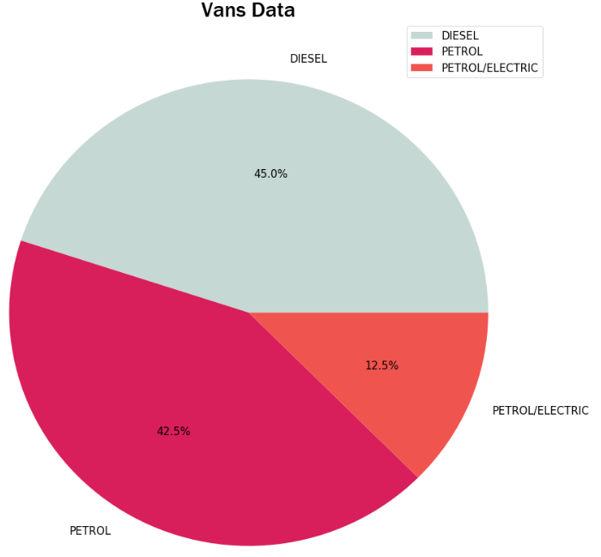

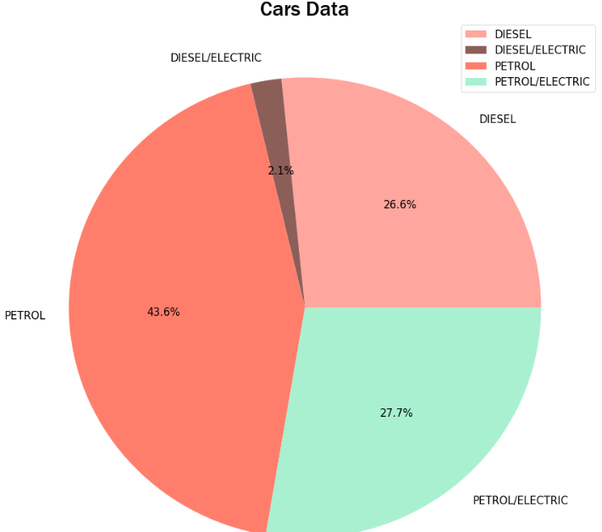

**Fig 1.1** Vehicle type: Cars. **Fig 1.2** Vehicle type: Vans.

With reference to Figure 1. Vehicles categorized into two types Car and Van, further categorized by fuel types. Most cars use environmentally harmful fossil fuels such as petrol and diesel, whereas only 12% of cars are hybrids, which are much more environmentally friendly and help save finite fossil fuels. By contrast, vans have a higher proportion of hybrid vehicles (up to 30 %). Although this is an improvement, the effective regulation of carbon emissions is still insufficient.

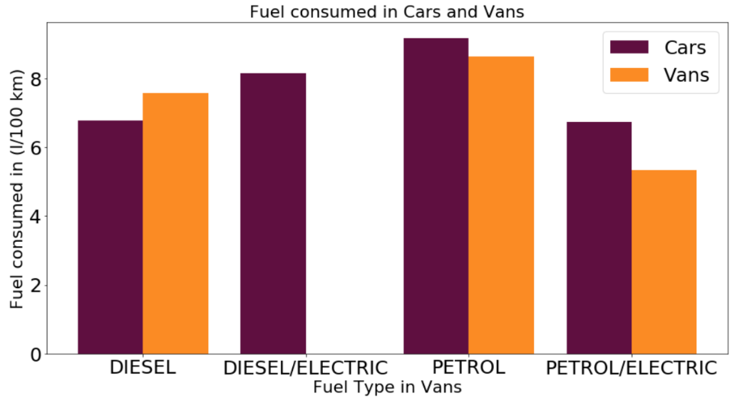

**Fig 2.** Fuel (in litres) consumed by different types of vehicles to travel a distance of 100 km

Cars fueled by fossil fuels, both petrol and diesel, consume comparatively larger amounts of fuel, whereas hybrid cars exhibit minimal fuel consumption to travel equal distances. Similarly, Vans using Hybrid fuel consuming less fuel when compared to vans with non-hybrid vehicles.

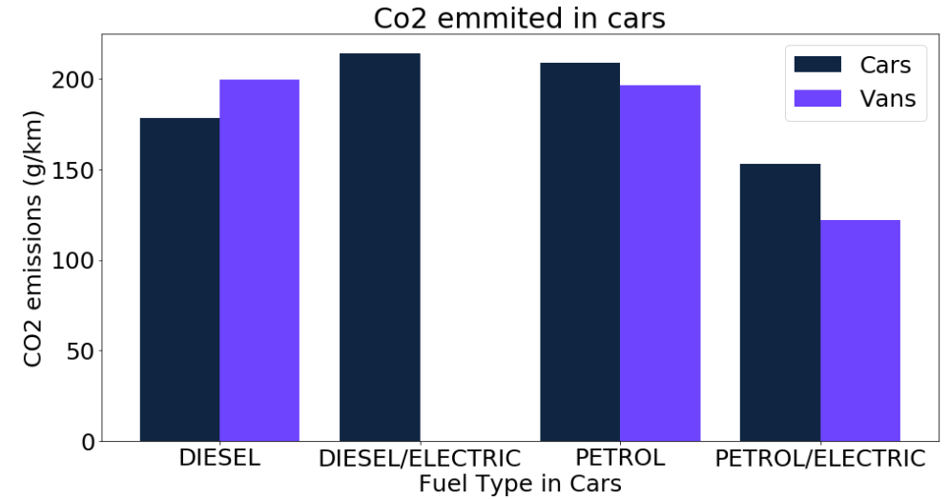

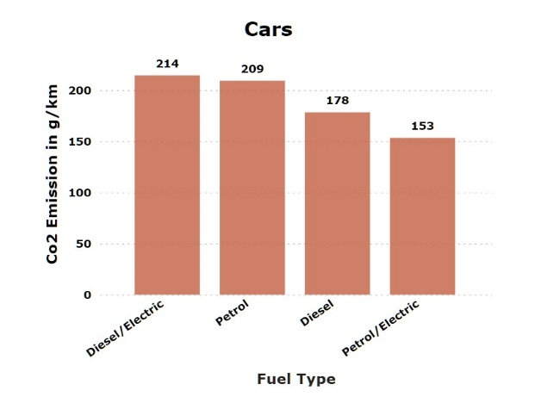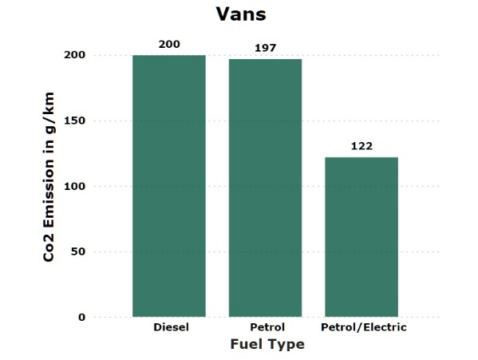

**Fig 3.** Fuel-type vs. CO2 emitted by different vehicles per 100 km.

As shown in the Fig.2. Cars fueled by fossil fuels, both petrol and diesel emit comparatively larger amounts of CO2 per KM, whereas petrol/electric hybrid cars exhibit minimal CO2 emissions per KM. Even in the vans vans with petrol and diesel 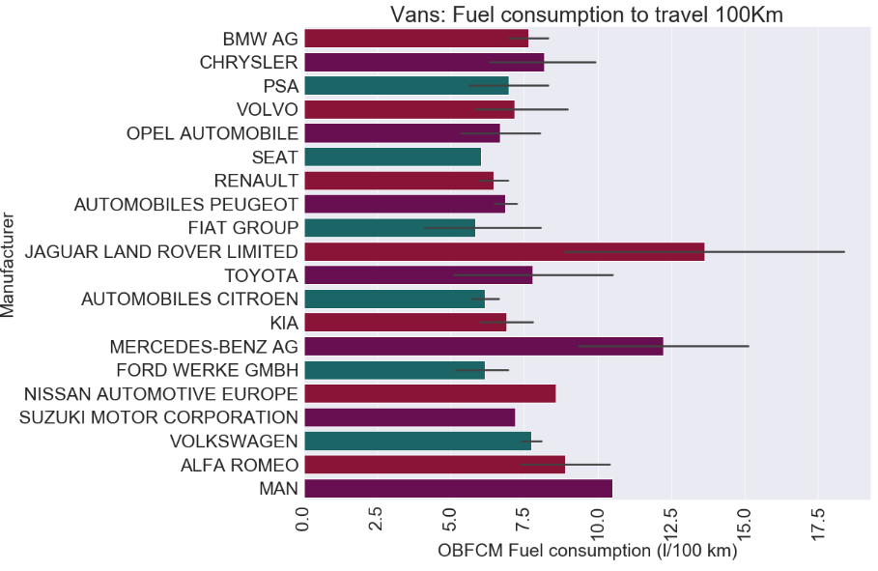as fuel emitting more per KM as compared to Hybrid vans.

**Fig 4.** The fuel efficiency of vans categorized by the manufacturer and make.

Manufacturers such as Rolls-Royce, Bentley, Ferrari, and Mercedes-Benz have the least fuel-efficient vans because they specialize in producing high-end luxury executive vans that prioritize luxurious features over fuel efficiency. These vehicles often include extravagant and unnecessary amenities, reflecting their emphasis on luxury rather than fuel-saving technology.

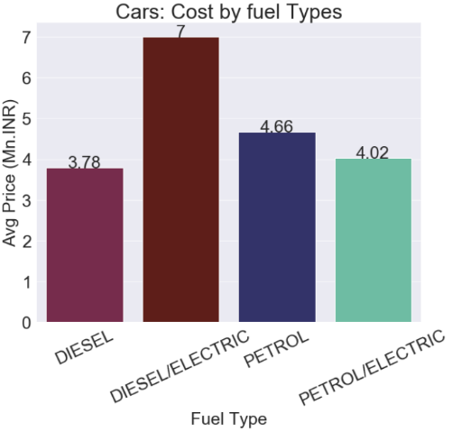By contrast, manufacturers such as CNG Technik, Suzuki, and Toyota prioritize fuel efficiency in their vans.

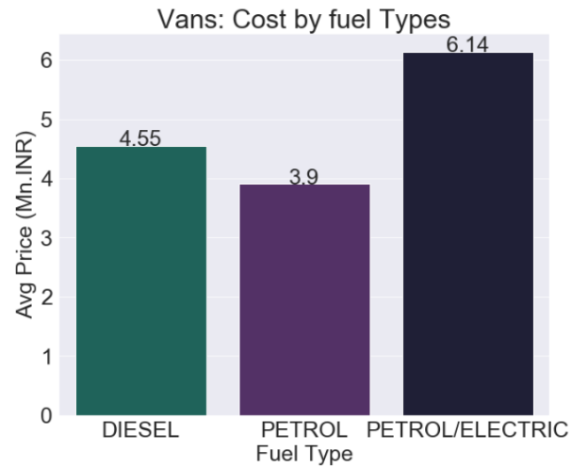

**Fig 5.1** Average cost of Vans categorized **Fig 5.2** Average cost of Vans categorized

by fuel type by fuel type

Vehicles that operate on traditional fossil fuels are comparatively cheaper compared to the Hybrid Electrical vehicles because of their complex engine design to incorporate different fuel energies. The hybrid vehicles are nearly 50% more expensive when compared to traditional fuel vehicles.

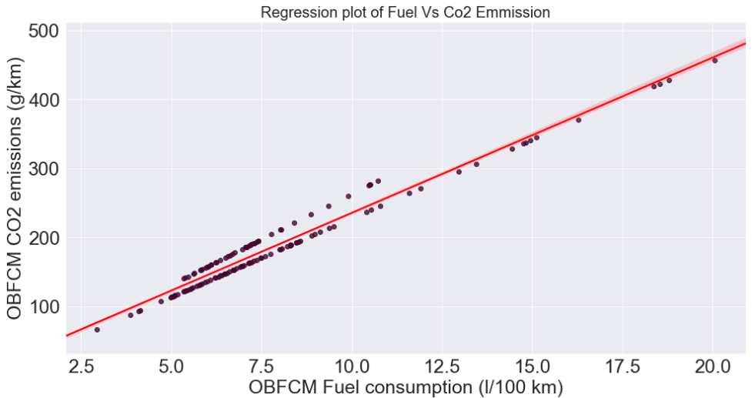

**Fig 6.** Understanding the relationship between Fuel Consumption and CO2 emissions

Based on the analysis of the scatter plot in the Fig.6. there is a clear indication that the relationship between fuel consumption and CO2 follows a linear trend.

**3.3 Model Building**

Our approach involves utilizing a diverse set of machine-learning models to forecast the desired output. As each new feature is extracted, it is seamlessly integrated into the evolving data frame, thereby enriching our dataset with valuable information.

From the fig.6 we can infer that there is positive correlation between fuel consumed by vehicle and CO2 emitted by vehicles. We can use this relationship to build a predictive model that provides CO2 emitted per KM for given fuel consumed by vehicle to travel 100 KM of distance. From fig7. we can build a linear regression model that predicts CO2 emitted per KM for a given fuel consumed to travel 100 KM of distance by a vehicle.

The model was trained using 80% of the processed aggregated data, which consists of 76 tuples which consists of focusing on fuel consumption and CO2 emissions. The remaining 20% of the aggregated data i.e., 36 tuples were used to test the model. We then verified the accuracy of the model by comparing the measured and predicted values, confirming its reliability and effectiveness in capturing the linear relationship between fuel consumption and CO2 emissions.

The linear regression equation is,

$$y = mx + c + e$$

Where y is CO2 Emitted

x is Fuel Consumed

m and c are constants

e is Standard error

Model for Cars,

*C02_Emmited = 13.89 + (22.05 * Fuel_Consumed)*

Model for Vans*,*

*C02_Emmited = 19.07 + (22.95 * Fuel_Consumed)*

1. Results

Formula to calculate accuracy,

*(Measured value - (Measured value – Calculated value)) /Measured Value*

Measured Value = Value measured by OBFCM device.

Calculated Value = Value Calculated by Model

In terms of Percentage,

*((Measured value - (Measured value – Calculated value)) /Measured Value) * 100*

Formula for error in percentage,

*100 - ((Measured value - (Measured value – Calculated value)) /Measured Value) * 100*

**Table 1.** Fuel consumes measure vs calculated values and accuracy in terms of percentage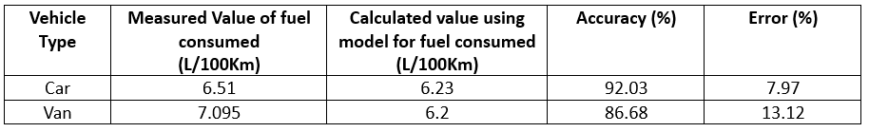

Table 1 displays the measured and calculated values of fuel consumption for automobiles and large vehicles. For cars, the measured value is 6.51 litters per 100 kilometres, while the modelled value is 6.23 litters per 100 kilometres, with an accuracy of 92.03% and an error of 7.97%. For vans, the measured value is 7.095 litters per 100 kilometres, while the modelled value is 6.2 litters per 100 kilometres, with an accuracy of 86.68% and an error of 13.12%. The model demonstrates a reasonable forecast of fuel consumption for both vehicle types, showing a greater accuracy and lower errors for cars compared to vans.

**Table 2.** For Co2 emitted measure vs calculated values and accuracy in terms of percentage

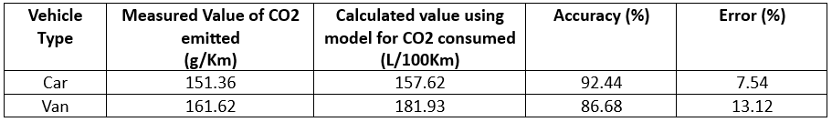

The table provides both the measured and model-calculated values of fuel consumption for cars and vans. For cars, the measured value is 6.51 L/100Km, while the model-calculated value is 6.23 L/100Km, with an accuracy of 92.03% and an error of 7.97%. For vans, the measured value is 7.095 L/100Km, while the model-calculated value is 6.2 L/100Km, with an accuracy of 86.68% and an error of 13.12%. The model demonstrates its ability to accurately predict fuel consumption for both vehicle types, with significantly greater accuracy and lower error rates for cars than for vans.

**5 Conclusion and Strategic Recommendations**

In our extensive examination of passenger vehicles' emissions, it is clear that although hybrid vehicles are considerably more eco-friendly, they are not as widely used as conventional vehicles that run on finite fossil fuels. The discrepancy in popularity can be attributed to several factors. There is a clear correlation between fuel consumption and CO2 emissions, where fuel consumption increases, CO2 emissions rise correspondingly. This relationship was confirmed using a Linear Regression Model. Hybrid vehicles are typically more expensive than traditional ones. Additionally, there are fewer companies involved in producing hybrid vehicles since their production rate is substantially higher than that of conventional vehicles.

To tackle the environmental challenges and encourage the use of eco-friendly vehicles, there are several crucial steps that must be taken.

First, it is essential to implement strict government regulations on emissions and fuel efficiency, such as the BS6 norms. These policies ensure that vehicles meet lower emission standards, significantly reducing their environmental impact. Providing Government subsidies to encourage people to move towards hybrid vehicles however, subsidy schemes will be repealed soon, which may cause EV market turbulence [16].  subsidies and non-economic incentives to support the adoption of electric vehicles can boast the adoption of electric vehicles [17].

Governments should introduce policies that encourage businesses to adopt business models with open innovation dynamics, promoting knowledge-sharing, and collaborative problem-solving ([Chaurasia et al., 2020;](https://www.sciencedirect.com/science/article/pii/S2199853124000118?via%3Dihub" \l "bib15) [Crupi et al., 2021;](https://www.sciencedirect.com/science/article/pii/S2199853124000118?via%3Dihub" \l "bib20) [Gurca et al., 2021](https://www.sciencedirect.com/science/article/pii/S2199853124000118?via%3Dihub" \l "bib46)). Financial incentives, grants, and tax breaks can be tailored to reward sustainable practices and the development of eco-friendly technologies. Open innovation engineering offers a structured approach to designing and implementing innovations ([Barham et al., 2020;](https://www.sciencedirect.com/science/article/pii/S2199853124000118?via%3Dihub" \l "bib133) [Obradović et al., 2021](https://www.sciencedirect.com/science/article/pii/S2199853124000118?via%3Dihub" \l "bib104)). Policymakers should advocate for the incorporation of engineering methodologies that prioritize sustainability and emissions reduction [20].

Second, manufacturers must be encouraged to innovate and produce environmentally friendly vehicles. By setting ambitious targets for reducing vehicular emissions, the transition towards hybrid and electric vehicles can be accelerated. This shift not only promotes cleaner transportation but also supports India's goal of achieving a net carbon zero status by 2070. Together, these measures pave the way for a sustainable future in the automotive industry. While hybrid vehicles have a smaller number of manufacturers compared to petrol/diesel vehicles, they are still more expensive, with prices ranging from 40-50% higher.

References

1. “Data Analytics Techniques for Environmental Pollution Analysis.” Written by Paawan Sharma, Anurag Kandya, and Vipin Shukla Available: [Data Analytics Strategies for Assessing Pollution Spread Using Sensor Data (ieee.org)](https://smartcities.ieee.org/newsletter/october-2022/data-analytics-strategies-for-assessing-pollution-spread-using-sensor-data#:~:text=IoT%20enables%20data%20capture%20with%20geo-tagging%20in%20order,in%20policy%20formulation%20to%20check%20pollution%20spread%20further.) (October 2022)
2. [Kriti Sahroha](https://ieeexplore.ieee.org/author/37089324762) and [Smily Chaudhary](https://ieeexplore.ieee.org/author/37089322741)’s “Real-Time Vehicle Emissions Monitoring Using IoT Sensors.” Available: [Vehicular Pollution Monitoring System using IoT: A Review | IEEE Conference Publication | IEEE Xplore](https://ieeexplore.ieee.org/document/9725694) on (December 2021)
3. “Predictive Modeling for Air Quality Forecasting.” Written by Yong Li, Lixia Wen & Xiaochao Deng Available: [Air quality prediction models based on meteorological factors and real-time data of industrial waste gas | Scientific Reports (nature.com)](https://www.nature.com/articles/s41598-022-13579-2). (Published: 03 June 2022)
4. T. Lakshmi Narayana,  C. Venkatesh, Adarsh Kumar’s “Advances in Sensor Technology for Real-Time Emissions Monitoring.” Available: [Advances in real time smart monitoring of environmental parameters using IoT and sensors - ScienceDirect](https://www.sciencedirect.com/science/article/pii/S2405844024042269) (15 April 2024)
5. P. Gireesh Kumar, P. Lekhana, M. Tejaswi’s “Impact of Vehicle Emissions on Urban Air Quality: A Review.” Available: [Effects of vehicular emissions on the urban environment- a state of the art - ScienceDirect](https://www.sciencedirect.com/science/article/abs/pii/S2214785320383620) (2021)
6. K. Kumar & B. P. Pande’s “Machine Learning Approaches for Predictive Modeling of Air Pollution.” Available: [Air pollution prediction with machine learning: a case study of Indian cities | International Journal of Environmental Science and Technology (springer.com)](https://link.springer.com/article/10.1007/s13762-022-04241-5) (2022)
7. Avinash Kumar Agarwal and Nirendra Nath Mustafis’s “Real-world automotive emissions: Monitoring methodologies, and control measures” Available: [Real-world automotive emissions: Monitoring methodologies, and control measures - ScienceDirect](https://www.sciencedirect.com/science/article/abs/pii/S1364032120309084) (March 2021)
8. [S M Ashrafur Rahman](https://www.researchgate.net/profile/S-M-Ashrafur-Rahman?_tp=eyJjb250ZXh0Ijp7ImZpcnN0UGFnZSI6InB1YmxpY2F0aW9uIiwicGFnZSI6InB1YmxpY2F0aW9uIn19), [I. M. Rizwanul Fattah](https://www.researchgate.net/profile/I-M-Rizwanul-Fattah-2?_tp=eyJjb250ZXh0Ijp7ImZpcnN0UGFnZSI6InB1YmxpY2F0aW9uIiwicGFnZSI6InB1YmxpY2F0aW9uIn19), [T M Indra Mahlia](https://www.researchgate.net/profile/T-M-Indra-Mahlia?_tp=eyJjb250ZXh0Ijp7ImZpcnN0UGFnZSI6InB1YmxpY2F0aW9uIiwicGFnZSI6InB1YmxpY2F0aW9uIn19) and [Fajle Rabbi Ashik](https://www.researchgate.net/profile/Fajle-Ashik?_tp=eyJjb250ZXh0Ijp7ImZpcnN0UGFnZSI6InB1YmxpY2F0aW9uIiwicGFnZSI6InB1YmxpY2F0aW9uIn19)’s “The rise of real drive emission to mitigate difference of lab tests and on-road emission” Available: [(PDF) The rise of real drive emission to mitigate difference of lab tests and on-road emission (researchgate.net)](https://www.researchgate.net/publication/345766742_The_rise_of_real_drive_emission_to_mitigate_difference_of_lab_tests_and_on-road_emission) (November 2020)
9. Sunil Kumar Pathak, Vineet Sood, Yograj Singh and S.A. Channiwala’s “Real world vehicle emissions: Their correlation with driving parameters” Available: [Real world vehicle emissions: Their correlation with driving parameters - ScienceDirect](https://www.sciencedirect.com/science/article/abs/pii/S1361920916000122) (May 2016)
10. Ricardo Suarez-Bertoa, Victor Valverde, Michael Clairotte, Jelica Pavlovic, Barouch Giechaskiel, Vicente Franco’s “On-road emissions of passenger cars beyond the boundary conditions of the real-driving emissions test” Available: [On-road emissions of passenger cars beyond the boundary conditions of the real-driving emissions test - ScienceDirect](https://www.sciencedirect.com/science/article/pii/S001393511930369X) (September 2019)
11. Zuoming Zhang, Hongyang Su, Wenbin Yao, Fujian Wang, Simon Hu, Sheng Jin’s “Uncovering the CO2 emissions of vehicles: A well-to-wheel approach” [Uncovering the CO2 emissions of vehicles: A well-to-wheel approach - ScienceDirect](https://www.sciencedirect.com/science/article/pii/S2667325823001930) (July 2023)
12. Yi Zhang, Ran Zhou, Shitao Peng’s “Development of Vehicle Emission Model Based on Real-Road Test” [Atmosphere | Free Full-Text | Development of Vehicle Emission Model Based on Real-Road Test and Driving Conditions in Tianjin, China (mdpi.com)](https://www.mdpi.com/2073-4433/13/4/595) (7 April 2022)
13. Hung-Ta Wen Jau-Huai Lu and Deng-Siang Jhang’s “ Features Importance Analysis of Diesel Vehicles’ NOx and CO2 Emission Predictions in Real Road Driving Based on Gradient Boosting Regression Model” [IJERPH | Free Full-Text | Features Importance Analysis of Diesel Vehicles&rsquo; NOx and CO2 Emission Predictions in Real Road Driving Based on Gradient Boosting Regression Model (mdpi.com)](https://www.mdpi.com/1660-4601/18/24/13044) (10 December 2021)
14. Youngeun Bae, Craig R. Rindt, Suman Kumar Mitra  and Stephen G. Ritchie’s “Fleet operator perspectives on alternative fuels for heavy-duty vehicles” | Features advantage of cleaner fuels over traditional fuels can provide significant potential to reduce green house gases | (April 2024)

[https://doi.org/10.1016/j.tranpol.2024.01.023](https://doi.org/10.1016/j.tranpol.2024.01.023                            )

1. Z. Thorne, L. Hughes “Evaluating the effectiveness of electric vehicle subsidies in Canada” | Features electric motors that are more efficient than internal combustion engines and are not directly associated with tailpipe emissions. |(2019)

<https://doi.org/10.1016/j.procs.2019.08.072>

1. Ning Wang, Linhao Tang, Wenjian Zhang and Jiahui Guo’s “How to face the challenges caused by the abolishment of subsidies for electric vehicles in China?” | Features The abrogation of subsidies will cause a sharp decline of electric vehicle sales. |(January 2019)

<https://doi.org/10.1016/j.energy.2018.10.006>

1. panelStephan Meisel, Tanja Merfelds “Economic incentives for the adoption of electric vehicles: A classification and review of e-vehicle services” | Features subsidies and non-economic incentives to support the adoption of electric vehicles.|( Augst 2018)

<https://doi.org/10.1016/j.trd.2018.08.014>

1. Directive 2009/28/EC of the European Parliament and of the Council of 23 April 2009 on the Promotion of the Use of Energy from Renewable Sources. (23 April 2009).

<https://eur-lex.europa.eu/legal-content/EN/TXT/PDF/?uri=CELEX:02009L0028-20151005&from=EN>

1. Lucian-Ioan Dulău’s “CO2 Emissions of Battery Electric Vehicles and Hydrogen Fuel Cell Vehicles” | Features comparison of co2 emissions by BEVs and FCEVs | (1 June 2023)

<https://doi.org/10.3390/cleantechnol5020035>

1. Aleksy Kwilinski, Oleksii Lyulyov, Tetyana Pimonenko ‘s “Reducing transport sector CO2 emissions patterns: Environmental technologies and renewable energy” | The research explores the impact of environmental technologies and renewable energy on carbon dioxide (CO2) emissions from the EU transportation sector | (March 2024)

<https://doi.org/10.1016/j.joitmc.2024.100217>